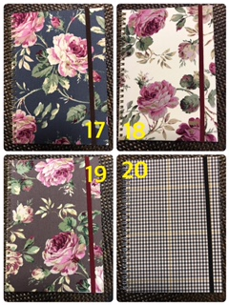

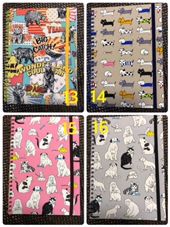

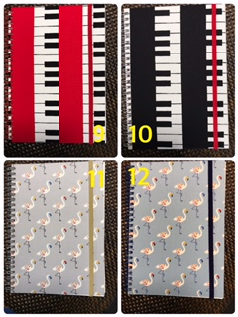

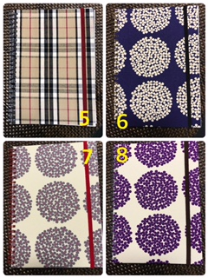

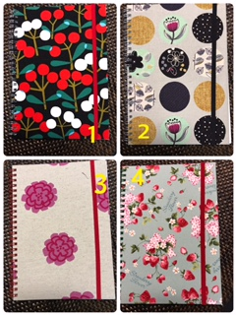

表裏とも生地使用分

|  |  |  |  |  |  |  |  |  |  |
| --- | --- | --- | --- | --- | --- | --- | --- | --- | --- |
|  |  |  |  |  |  |  |  |  |  |
| 2 | ２ |  | 2 |  |  |  |  | 1 |  |
|  |  |  |  |  |  |  |  |  |  |
| 1 |  | 1 |  | 2 |  |  | 2 | 1 |  |

㉑　１と色違い柄　3

